Vibration and Acoustic data for defect cases of the cylindrical roller bearing
Anil Kumar and Rajesh Kumar
Precision Metrology Laboratory, Mechanical Engineering Department,
Sant Longowal Institute of Engineering and Technology, Longowal, India
Link: https://drive.google.com/file/d/1IZ5Ox1k_ctfpXEcWwTesru_FEJ-88neL/view?usp=sharing
Introduction: This document has description of cylindrical roller bearing (NBC: NU205E) defect data, the Test rig facility, sensor, and data acquisition device located at Precision Metrology Laboratory, Mechanical Engineering Department of Sant Longowal Institute of Engineering and Technology Longowal, India. This data can have the following applications:
- Test the performance of various signal processing techniques.
- Defect width measurement using vibration data
- Development of Artificial intelligence models for defect identification
- Performance of AI model can be tested on unseen data.
For example, an AI model which is developed from conditions mentioned in Table 2 can be used to check the accuracy of the model using unseen data for condition mentioned in Table 3.

- Test Rig
Fig. 1 is the typical photograph of the rolling element bearing test rig. Its schematic diagram is shown in Fig. 2. The shaft is supported by two bearings at its end (bearing 1 and bearing 2). A 346-Watt AC motor provides power to the shaft. The power from the motor is transferred to the shaft via a step pulley arrangement. In the middle of the shaft (between bearings 1 and 2), a 2 kg disc is attached to the shaft and rotates with it. A lever arrangement is used to load the bearing in the vertical direction. A load cell is located beneath the bearing housing on the test rig to measure the applied load. The test rig has a proximity sensor for the measurement of shaft speed. The vibration signals from the test rig were measured by mounting an accelerometer on the top of the bearing housing. All the signals acquired in this work were recorded at a sampling rate of 70000 samples/sec.
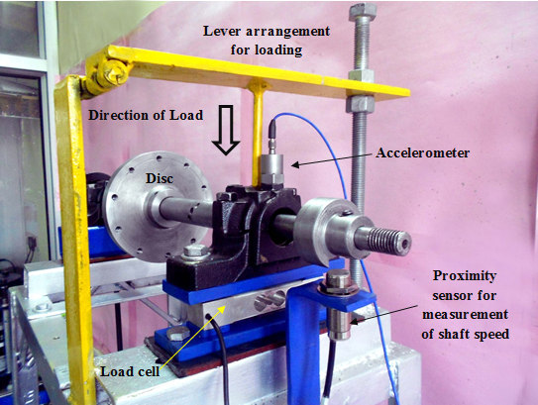
Fig. 1. A typical photograph of the test rig

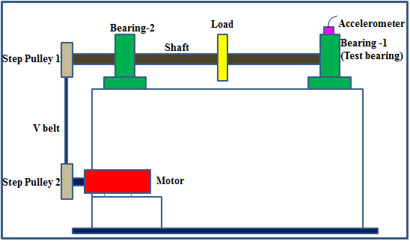
Fig. 2. A typical photograph of the test rig

- Test Bearing
The test bearing is a cylindrical roller bearing (NBC: NU205E). The specifications of the bearing under study are given in Table 1. A total of twelve defect cases were studied, the detail of which is given in Table 2. All the defects are in the form of rectangular grooves which are produced by the Electric discharge machining (EDM) process. The defective components of bearing under study are shown in Fig. 3-5. The experiment was conducted at a shaft speed of 2050 rpm and at a vertical load of 200 N. -
The conditions listed in Table 2 can be used to construct (train and test) an AI model. Testing the same model can be done to assess how well it performs with unknown data. Table 3 has detail of data that can be used as unseen data. The concept of transfer learning can also be used here.
Table 1: Specifications of the cylindrical rolling bearing under study (NBC: NU205E)
Diameter (Inner race) | 25 mm
Diameter (Outer race) | 52 mm
Pitch Diameter (D) | 38.9 mm
Ball Diameter (d) | 7.5 mm
Number of rolling elements (N) | 13
Contact angle ($φ$) | 0$˚$

Table 2: Defect cases of the cylindrical roller bearing understudy obtained at a shaft speed of 2050 rpm and load of 200 N
Bearing component | Label | Defect width  (in mm)
Inner race | IR-I | 0.43
Inner race | IR-II | 1.01
Inner race | IR-III | 1.56
Inner race | IR-IV | 2.03
Outer race | OR-I | 0.42
Outer race | OR-II | 0.86
Outer race | OR-III | 1.55
Outer race | OR-IV | 1.97
Roller | RO-I | 0.49
Roller | RO-II | 1.16
Roller | RO-III | 1.73
Roller | RO-IV | 2.12

Table 3. Defect sizes of the cylindrical roller bearing different from the cases mentioned in the Table 2.

Defective component | Defect size  (in mm)
Inner race | 1.85 mm
Outer race | 1.34 mm
Roller | 0.75 mm

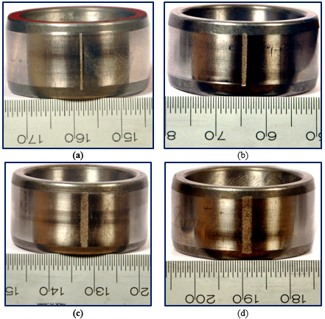
Fig. 3. Typical photographs of inner races having defect (a) IR-I defect (b) IR-II defect (c) IR-III defect and (d) IR-IV defect
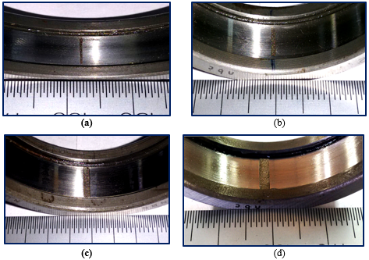
Fig. 4. Typical photographs of outer races having defect (a) OR-I defect (b) OR-II defect (c) OR-III defect and (d) OR-IV defect
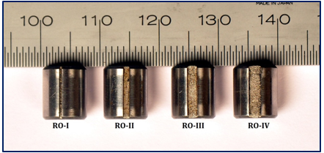
Fig. 5. A typical photograph of defective rollers
- Data Acquisition device: The data acquisition device used to acquire vibration and acoustic data is NI-USB-4431, which is a portable data acquisition device and is shown in Fig. 6. The NI-USB-4431 has signal conditioning modules with a low-pass Bessel filter for aliasing reduction.
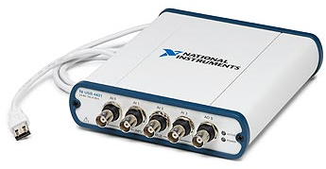
Fig. 6. A typical photograph of DAQ (NI-USB-4431)
The device has 4 input channels (ai0, ai1, ai2, and ai3) that can acquire voltage in the range of ±10 V. It has 1 analog output channel (±3.5 V) and has a sample update rate of 96 kS/s. The device has 24-bit resolution and has software-selectable IEPE signal conditioning (0 or 2.1 mA).

- Acoustic and Vibration Sensor
Acoustic and vibration data were recorded using a microphone and tri-accelerometer which can record the data in three axes.
The Acoustic emission sensor used for acquiring the data is shown in Figure 7 and is connected to ai3 channel of accelerometer. The specification of the microphone is shown in Table 4.
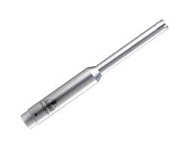
Fig. 7. Microphone used for data acquisition
Table 4. Specifications of microphone
Manufacturer | BEHRINGER
Model No. | ECM8000
Type | Electret Condenser
Polar pattern | Omni-directional
Impedance | 600 Ohms
Sensitivity | -60 db
Frequency response | 15 Hz - 20 kHz
Phantom Power | +15 V to +48 V
Weight | 0.120 kg

The accelerometer is a lightweight (1.0 gm) miniature, ceramic shear ICP® Triaxial accelerometer (model no PCB3456A01) having a sensitivity of 5 mV/g, Sensitivity: (±20%) 5 mV/g (0.51 mV/(m/s²)) and Measurement Range: ±1000 g pk ( ±9810 m/s² pk). Fig. 8 shows a typical photograph of the accelerometer.

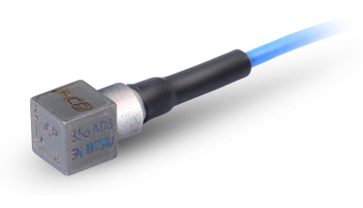
Vertical direction connected to ai0 channel
Horizontal direction connected to ai1 channel

Axial direction (Shaft axis direction) connected to ai2 channel

Fig. 8. Accelerometer used for data acquisition

Interested researchers who intend to use this data should cite following relevant publications
- Anil Kumar, Yuqing Zhou, C.P. Gandhi, Rajesh Kumar, Jiawei Xiang. (2020) Bearing defect assessment using wavelet transform based deep convolutional neural network (DCNN). Alexandria Engineering Journal 59, 999–1012 (Elsevier). I.F.: 3.73 ISBN: 1110-0168. Available online at: https://doi.org/10.1016/j.aej.2020.03.034
- Anil Kumar and Rajesh Kumar (2017) Enhancing weak defect features using undecimated and adaptive wavelet transform for estimation of roller defect size in a bearing. Tribology Transactions. 60(5): 794-806 (Taylor and Francis publication, Impact Factor: 1.96). Available online at: http://doi.org/10.1080/10402004.2016.1213343. ISBN: 1547-397X
- Anil Kumar and Rajesh Kumar (2017) Least Square Fitting for Adaptive Wavelet Generation and Automatic Prediction of Defect Size in the Bearing Using Levenberg–Marquardt Backpropagation. Journal of Nondestructive Evaluation. 36 7: 1-16 (Springer publication, Impact Factor: 1.99). Available online at: http://doi.org/10.1007/s10921-016-0385-1. ISBN: 1573-4862

Contributors


Dr. ANIL KUMAR

Email: anil_taneja86@yahoo.com
SCOPUS ID: https://www.scopus.com/authid/detail.uri?authorId=57202522777


Professor Rajesh Kumar
Email: rajesh_krs@sliet.ac.in; rajesh_krs@rediffmail.com
SCOPUS ID: https://www.scopus.com/authid/detail.uri?authorId=7406019891

